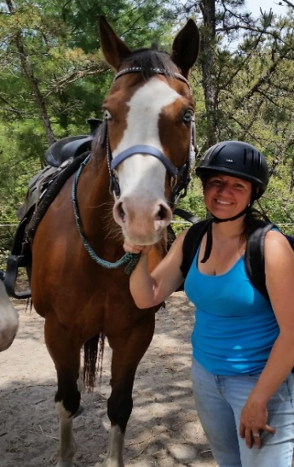

Dawn Boudros

CPR certified • First Aid Trained
4-H Leader• Reiki Practioner

▼ Background
Dawn has had a love for horse at a young age. She participated for years in 4-H horse shows in Massachusetts. She started off doing lead line on her sister’s horse, Speck. Then riding a spunky welch pony named, Bucky. She stopped riding for a while until having a horsey loving daughter, Melina who started riding with us in 2013. Since then, she helps with on property and off property horse shows, summer camps, camping trips and all around helping at the barn with chores.

▼ Training Experience
Dawn in currently mentoring at Follow Your Dreams working towards her Massachusetts riding instructor license. She has completed and passed the written portion and is now working on her teaching hours for her license.

Dawn is currently mentoring at Strongwater Therapeutic Equestrian Center in Tewksbury, MA. She is working towards her certification for the Professional Association for Therapeutic Horsemanship (PATH). This Equine-Assisted program helps riders and non-riders of all ages and disabilities interact with horses with amazing rewards.

▼ Achievements
In 2019, she purchased a Pony of America, Dan. She loves to trail ride with him. In knowing that horses are herd animals, she rescued 2 miniature horses, Dandy and Sheldon. Not sure of their background, she worked with her daughter, Melina to train them with general ground manners, in-hand horsemanship and jumping. She is currently working with Dandy to drive.

Dawn has been a 4-H leader for 2 groups for 9 years, Derry Dream Catchers and Nutfield Hunt Club. She is currently the Rockingham County Horse Leader Association secretary for 5 years. She is very actively involved with the Rockingham County Circuit, County, and State horse shows for New Hampshire.

